**Hospital Management System**

This is a hospital management user interface for managing, monitoring and controlling the system in a Hospital. This application is developed in java, which mainly focuses on basic operations in a hospital like adding new patient information, and updating new information, assigning the doctor for patient. It features a familiar and well thought-out, an attractive online user interface, combined with strong searching Insertion and reporting capabilities. The Backend of the project is designed with Java, MySQL for database connectivity and front end using HTML, CSS, and Bootstrap.

**Screenshots**

**Homepage**

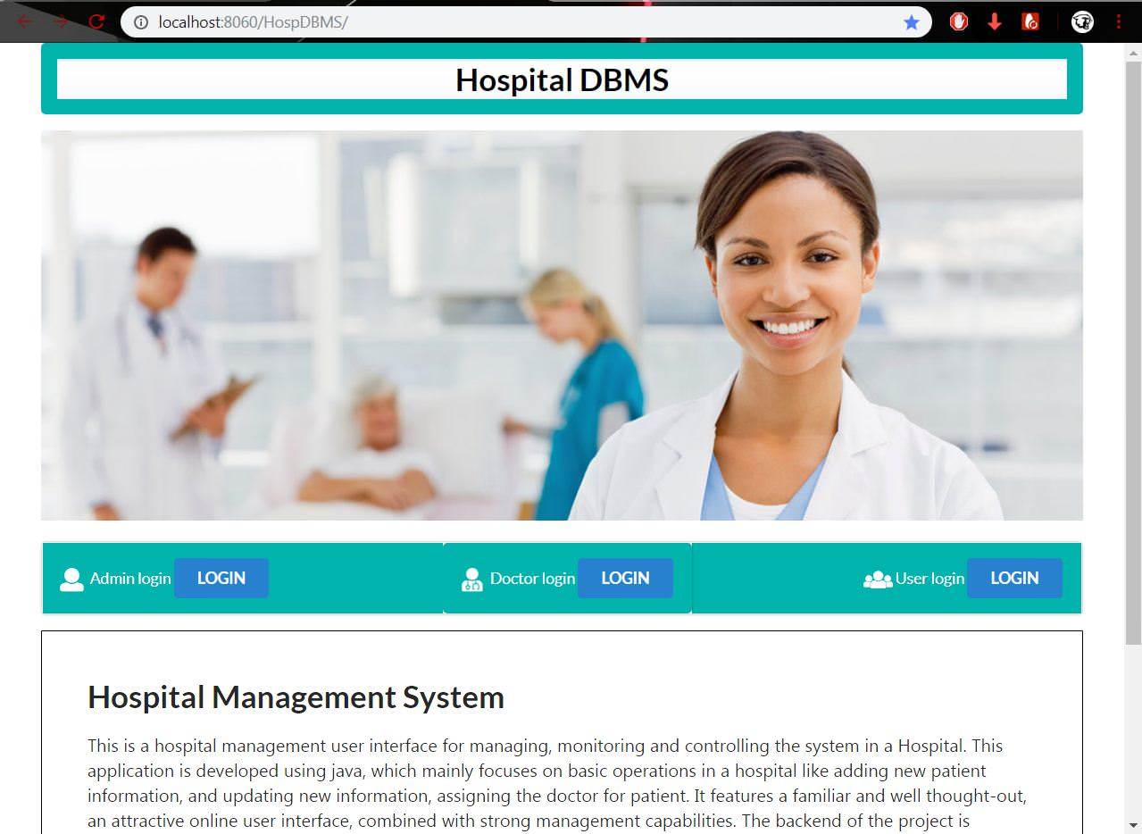

The view pages means sign in, register, dashboards etc. will be created in jsp and the controller will be for business logic

1: If the user is doctor he can see the list of patients in his dashboard.

2. If the user is Patient he can login with his credentials and can book the appointment through his dashboard both dashboard will be different.

3. Sign in validations from the databases.

4. User tables and doctors table and appointment table, Patients table will be there in mysql

**Login pages**

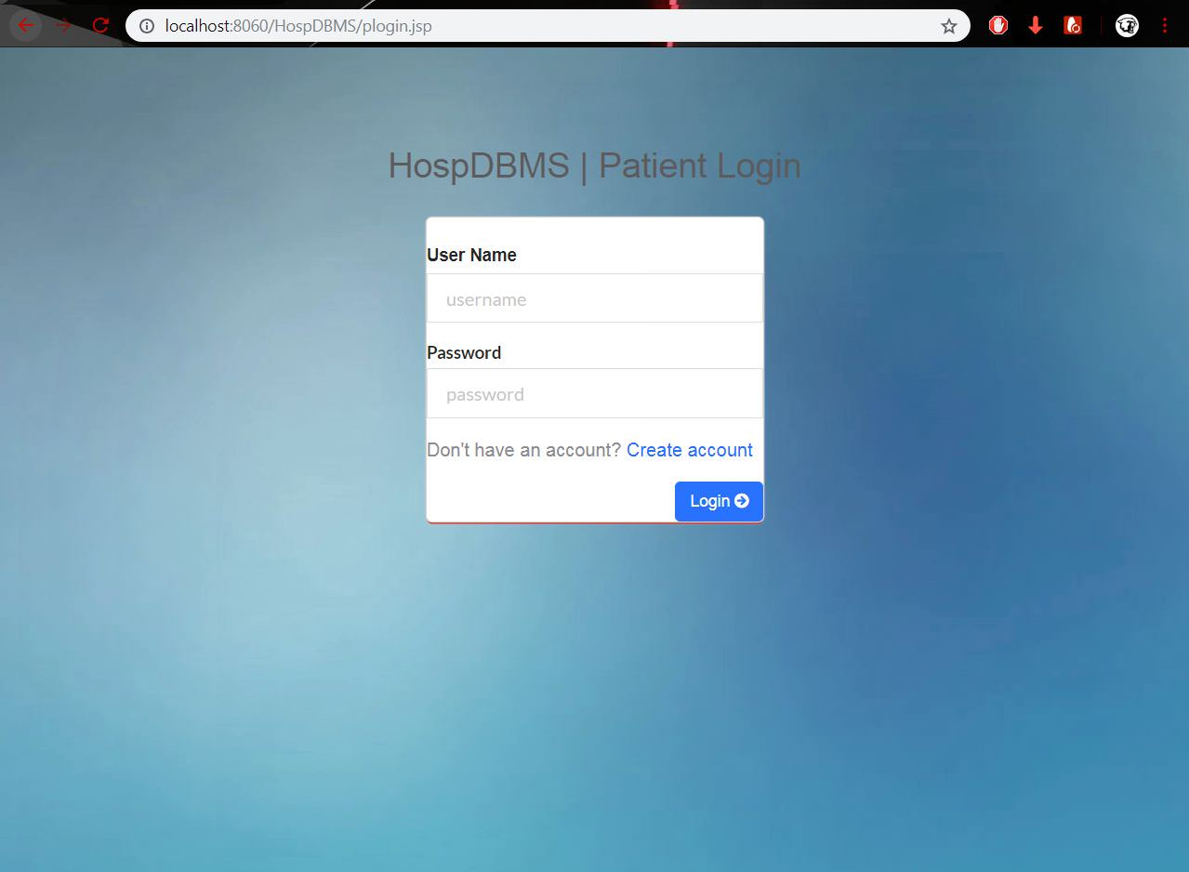

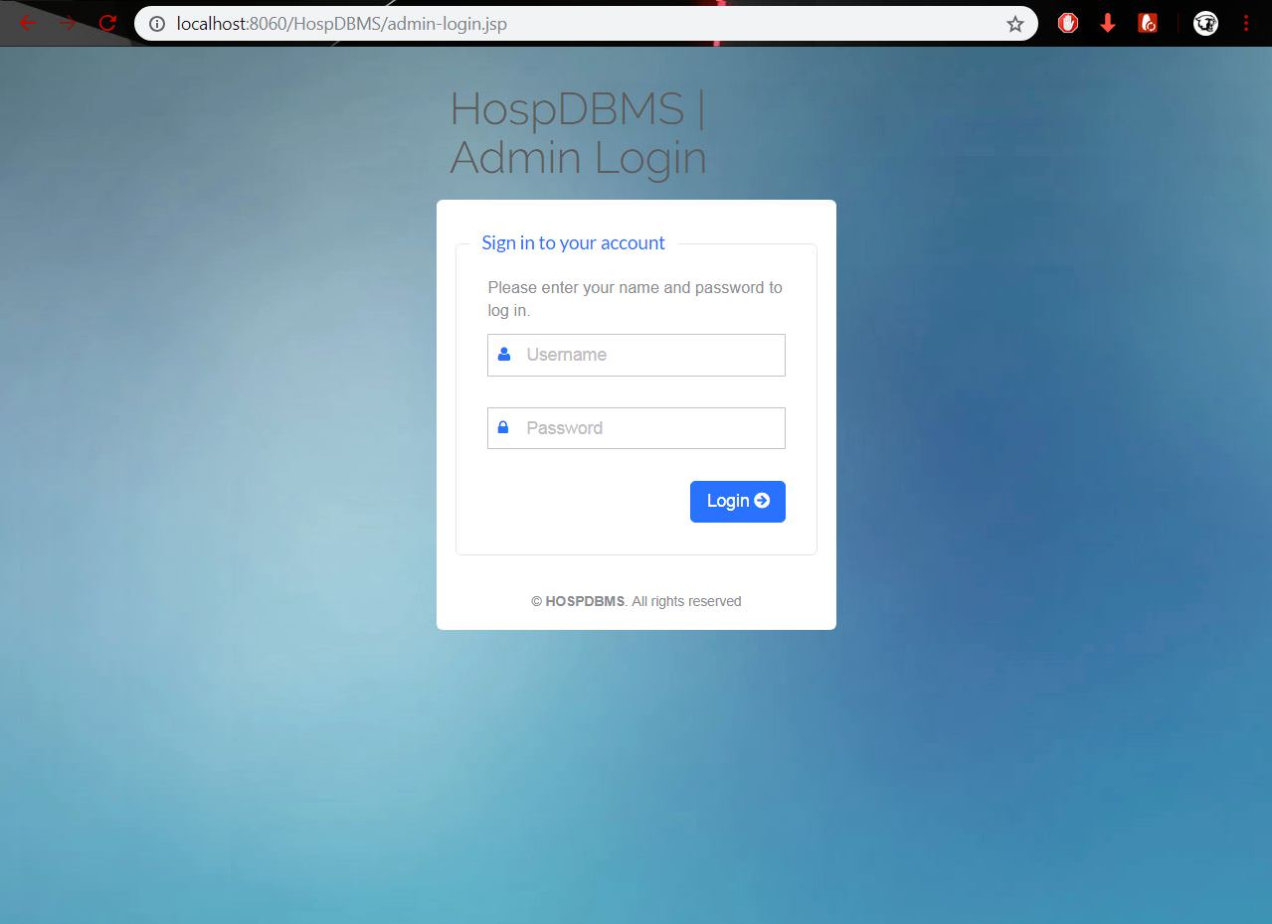

**Dashboard**

